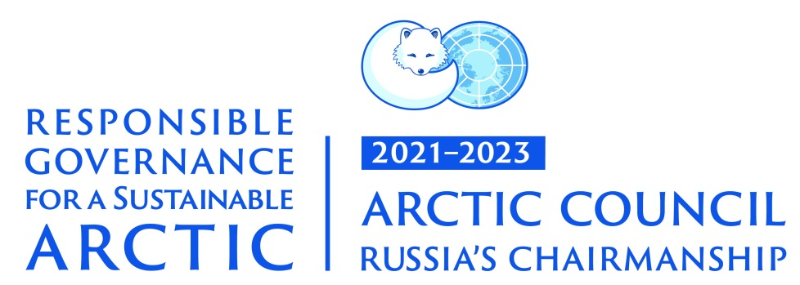
 | 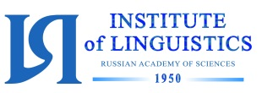 | 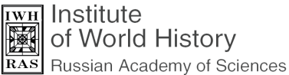 | 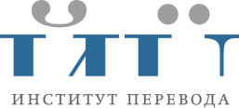

International Conference
THE ARCTIC: DEVELOPMENTS FROM THE PERSPECTIVE
OF THE HUMANITIES
Dear colleagues,
Moscow State Linguistic University, in conjunction with
the Institute of Linguistics and the Institute of World History
of the Russian Academy of Sciences, and the Institute for Literary Translation invites you to attend the international conference:
“The Arctic: Developments from the Perspective of the Humanities”,
to be held in Moscow on the 15th-16th of February, 2022
within the framework of Russia’s chairmanship of the Arctic Council.
The conference is expected to cover a broad range of subjects related to humanities and social science research of the Arctic and the Far North, including:
- research and description of the languages of the Arctic region;
- problems and perspectives of preserving the languages of the Arctic region;
- the study and preservation of the linguistic and cultural heritage of indigenous peoples;
- language and cultural policy in the Arctic and Sub-Arctic regions;
- the art and folklore of indigenous peoples of the North;
- the socio-biology and socio-psychology of human populations in circumpolar regions;
- ethnocultural processes in the context of current social change, the interrelation of traditional culture and global processes in the modern world;
- the history of Arctic exploration, the history of intercultural communication in the region;
- the development of human capital in the Arctic region;
- the development of ecological tourism in the Arctic.
The list of subjects for discussion is not final, and the Organising Committee will be grateful for any further suggestions.
The working languages at the Conference are Russian and English.
Participants who cannot attend the Conference will be able to give their presentations via Zoom.
The Conference starts at 10 a.m. on 15th of February, 2022, with registration beginning an hour earlier, at 9 a.m.
Presentations at the plenary session should not exceed 20 minutes, and the time limit for all other presentations is 10 minutes.
The Organising Committee invites all those who wish to take part in the Conference to submit their applications (see the form below) and abstracts, in an attached file, not later than the 15th of November, 2021 to arctic@linguanet.ru. Please make sure you fill in all the fields in the application form.
We hope to receive your abstracts in time, as we are planning to publish them online at the Russian Scientific Electronic Library website at elibrary.ru before the Conference starts.
Reports selected by the Programme Committee will be published in a special issue of MSLU’s journal.
You can find more information about the Conference at its website at https://arctic.linguanet.ru
The Organising Committee’s contact details are as follows:
Anastasia Skachkova, lecturer at the Department of Scandinavian Languages, Dutch and Finnish of Moscow State Linguistic University;
phone number: +7 925 9144731
e-mail: arctic@linguanet.ru
Evgenia Vorobyеva, head of the Department of Scandinavian Languages, Dutch and Finnish of Moscow State Linguistic University;
phone number: +7 985 1304643
e-mail: scandinavian@linguanet.ru

APPLICATION
to take part in the conference
“The Arctic: Developments from the Perspective of the Humanities”

First name
Last name
Country
Organisation (research centre, university, etc.) – please, write the full name
Department – please, write the full name
Position
Academic credentials
The title of your presentation at the plenary session or at a panel

The subject to be discussed at the Conference that interests you

Participation format (in person, online)
Use of PowerPoint
Phone number
E-mail

